**UML - NIKHIL ARORA – A20339503**

**ASSIGNMENT NO: 2**

Deliverables:

Q 1: Any Three System Sequence Diagrams for the use-case diagram you created in Assignment #1

Ans:

* 1. – Update Order

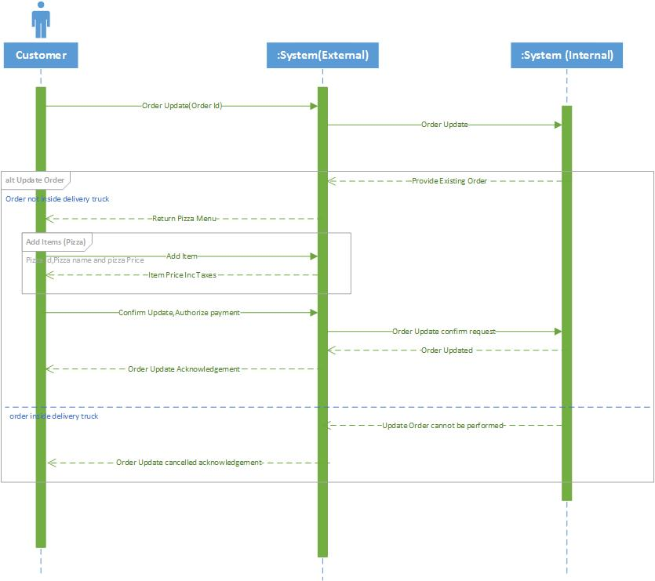

1.2 – Add / Delete Pizza Items

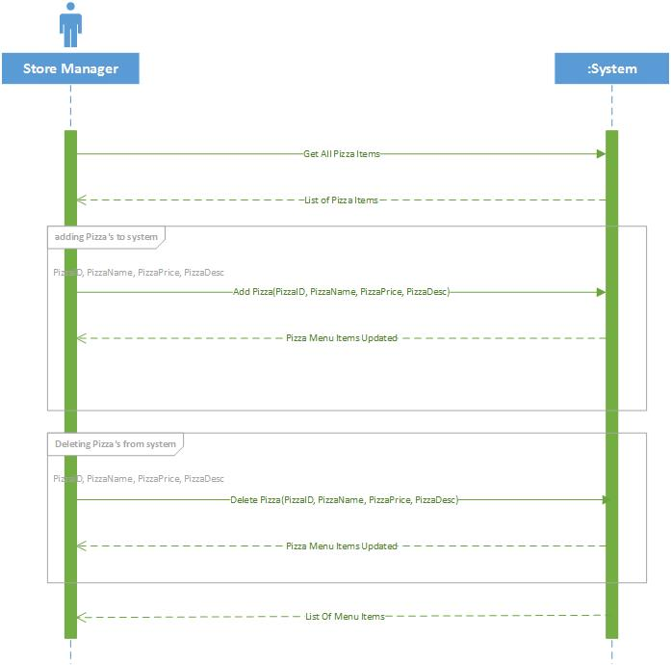

1.3 – Add / Delete Coupons

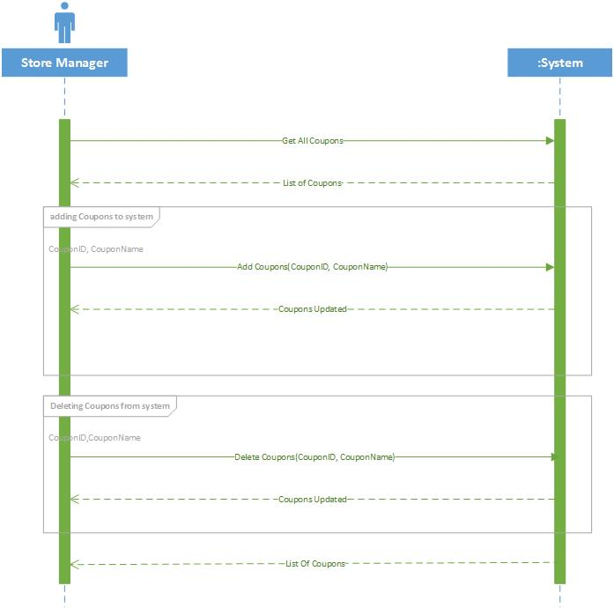

Q-2: The Class diagram for your analysis model

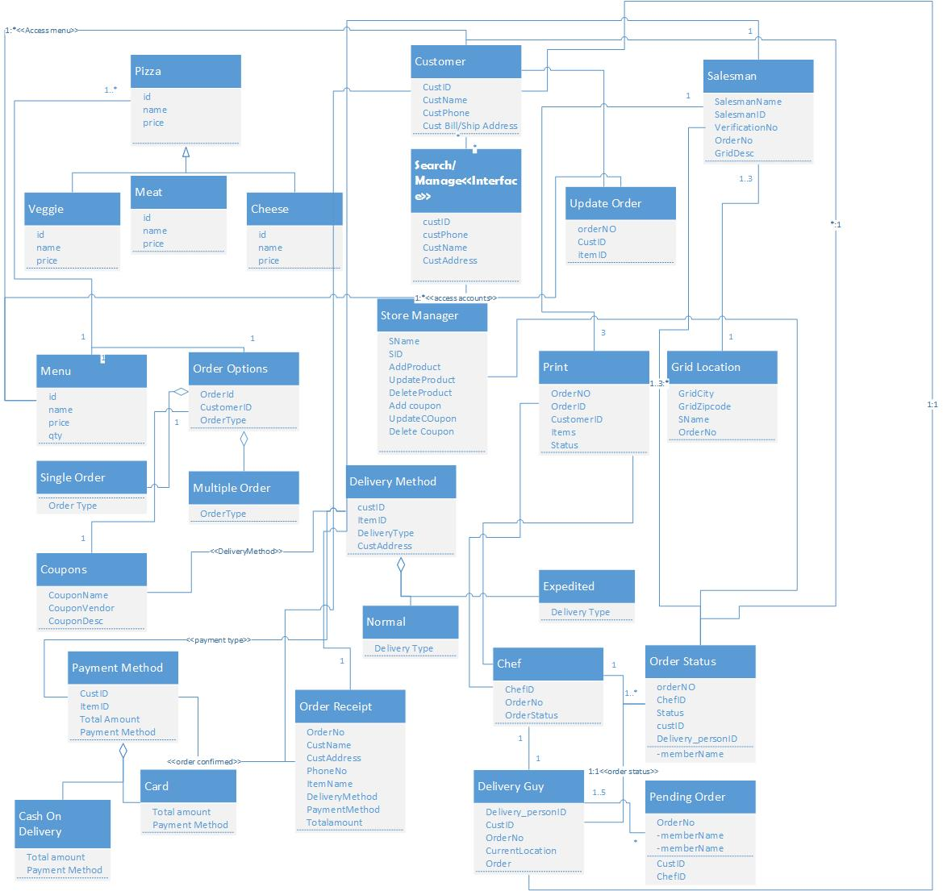

Q-3: The Class diagram and package diagram for your design model

Ans: 3.1 – Class Diagram

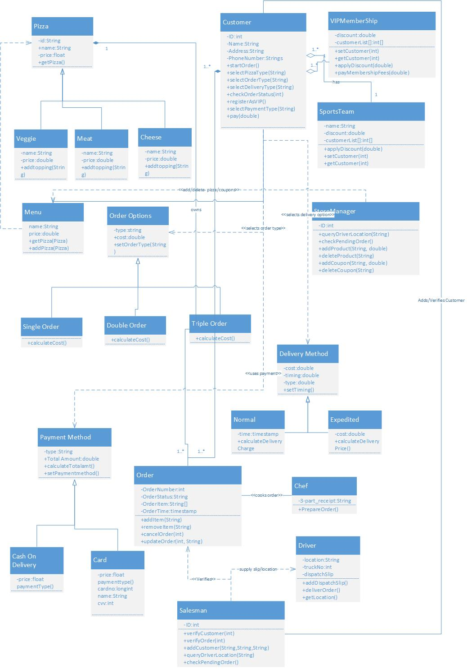

3.2 – Package Diagram

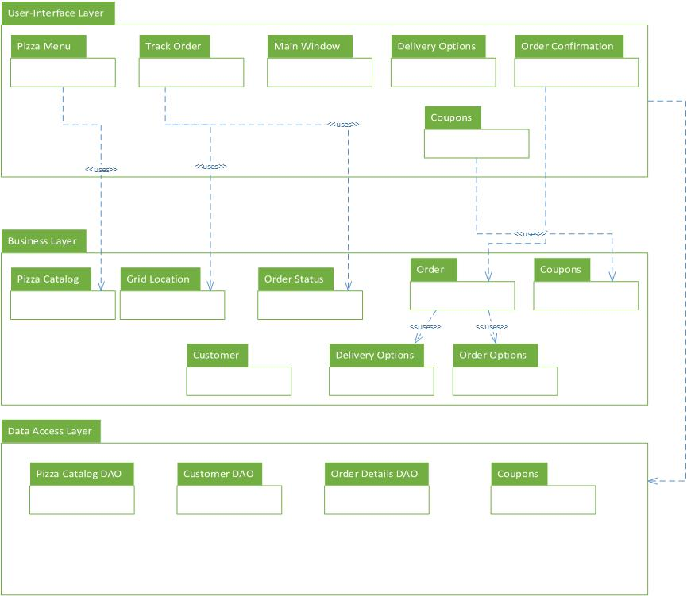

Q-4: Any Five sequence interaction diagrams that you can pick form the list of potential sequence interaction diagrams for your design model.

4.1 - Sequence Interaction Account Verification

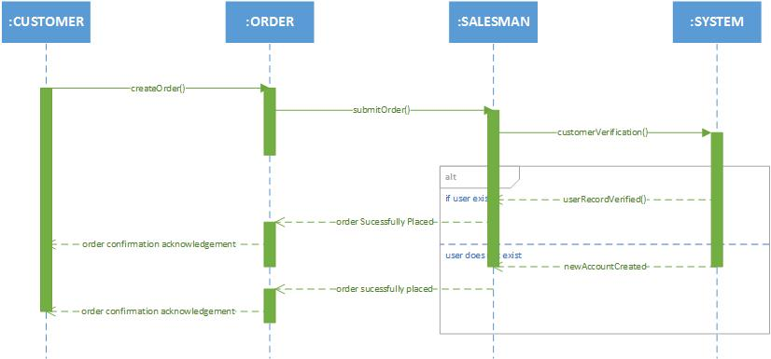

4.2 - Sequence Interaction Add / Delete Pizza

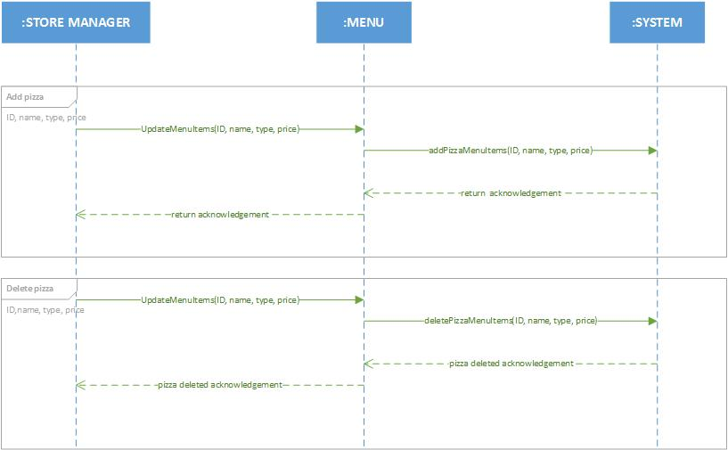

4.3 – Sequence Interaction Update Order

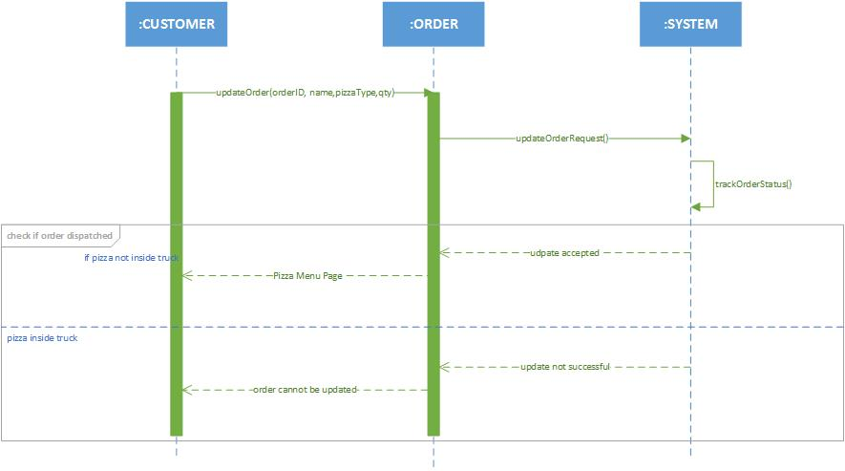

4.4 – Sequence Interaction Create Order

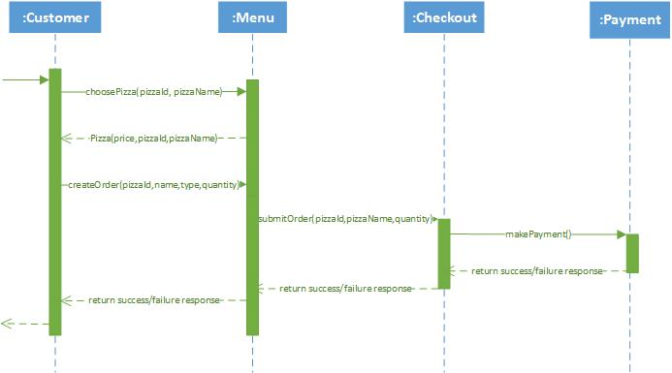

4.5 – Sequence Interaction Order Cancel

